1. Create one VPC, with 1 public subnet and 1 private subnet.

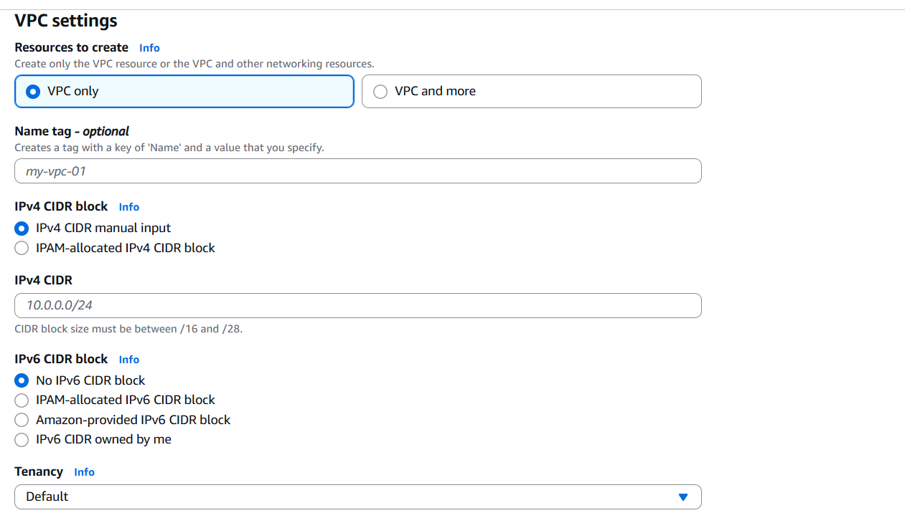

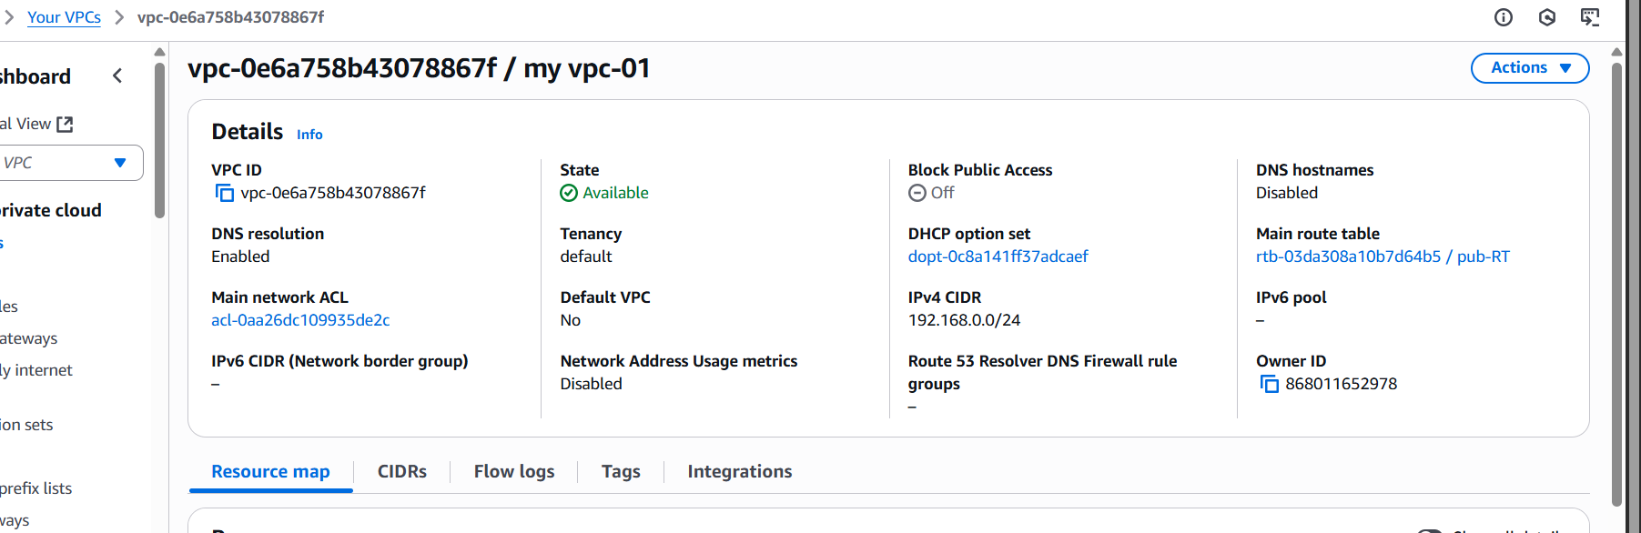

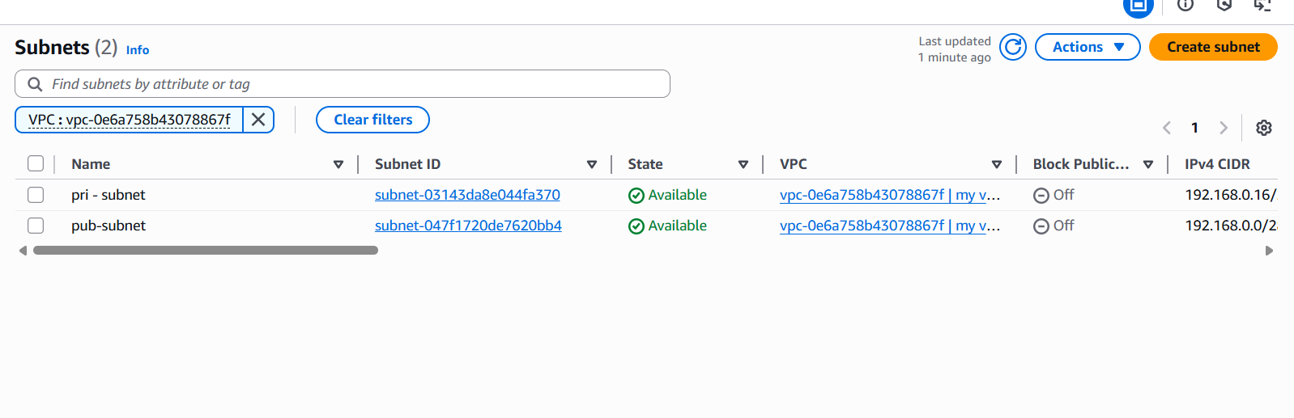

1. Enable VPC peering for cross-region.

MUMBAI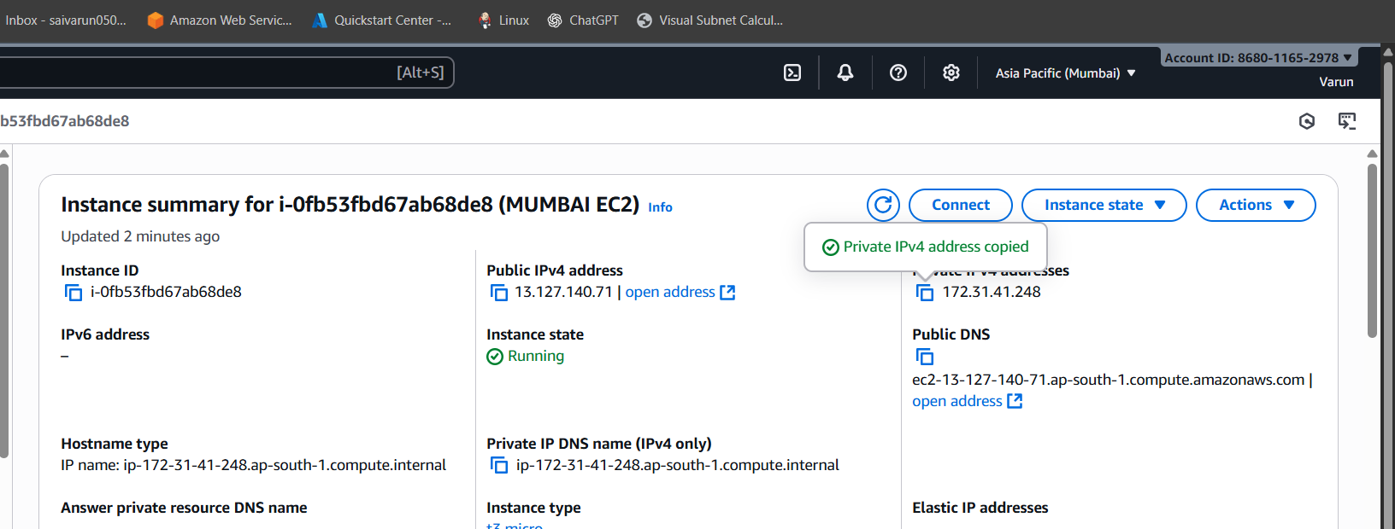

CANADA

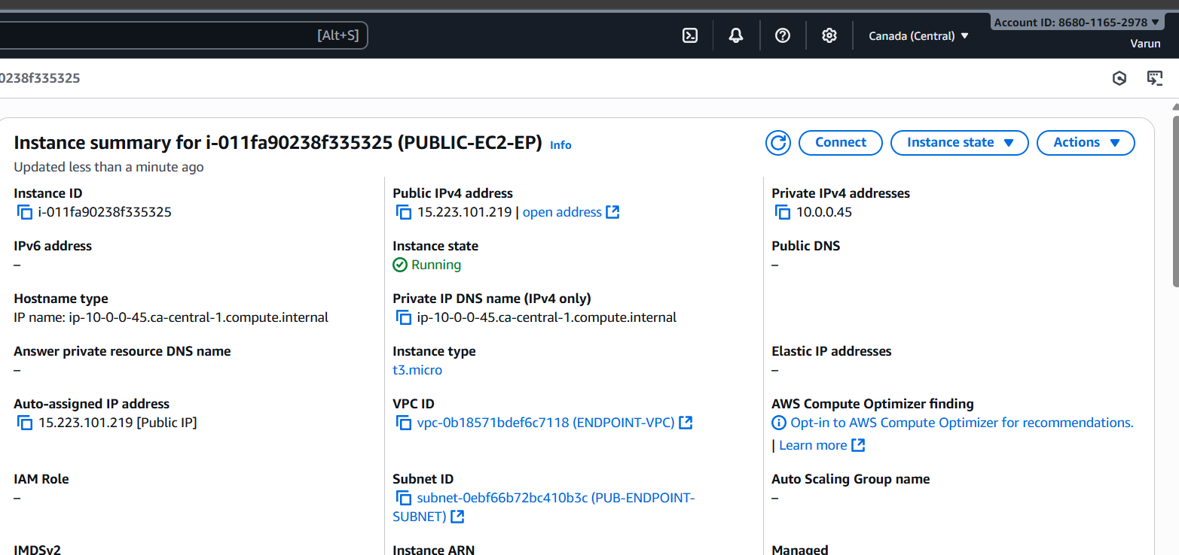

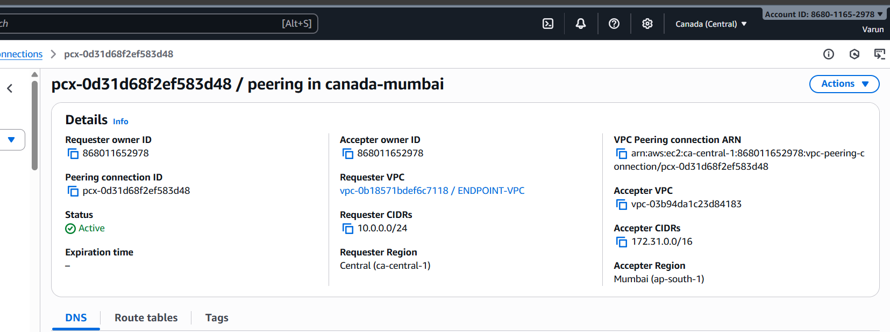

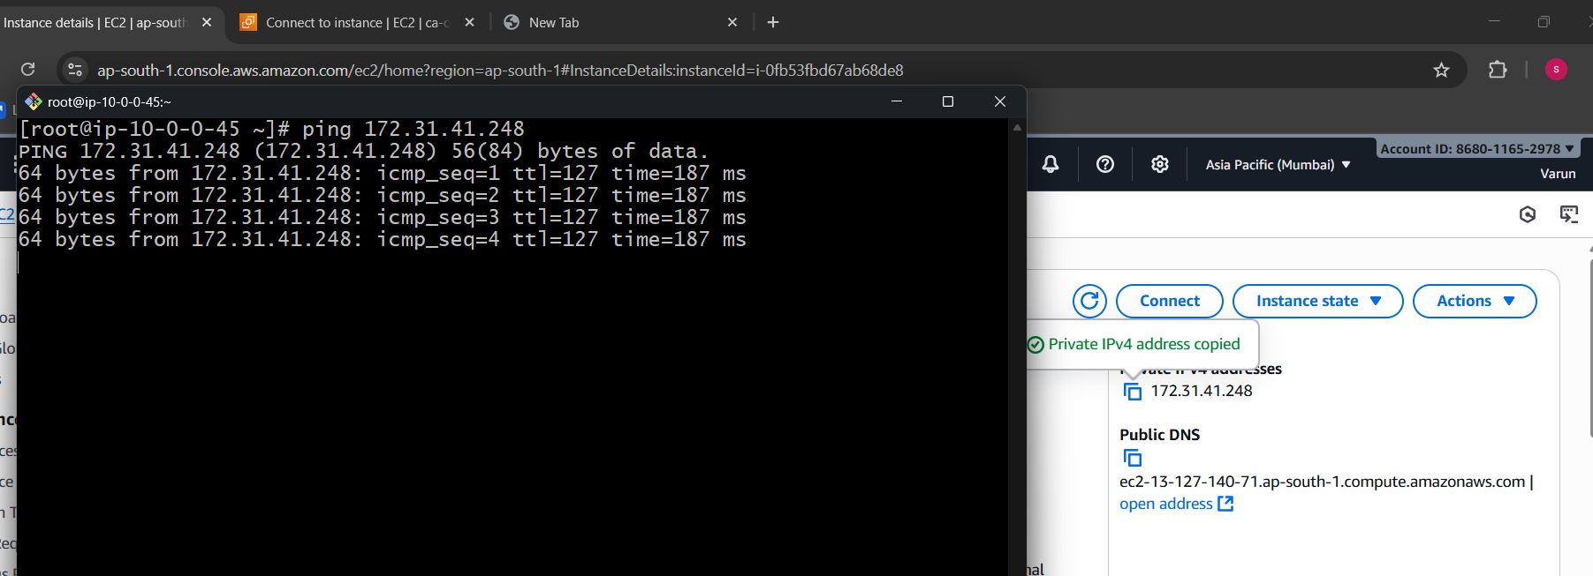

* Create 1 ec2 in Mumbai with vpc connected to it and it should be public.
* Create 1 ec2 in Canada with vpc connected to it and it should be public too.
* Now try to connect Canada instance with Mumbai’s by creating a peering request and accept it from the other end user.
* Once the connection is established configure the same in route tables by giving the vpc ids and peering connection ids in each other.
* Now try to connect to instance in Canada and ping to mumbai’s private ip address.
* We can see the connection establishment between this two regions.

1. Enable VPC peering for cross-account (you can collaborate with your friend to do this task).

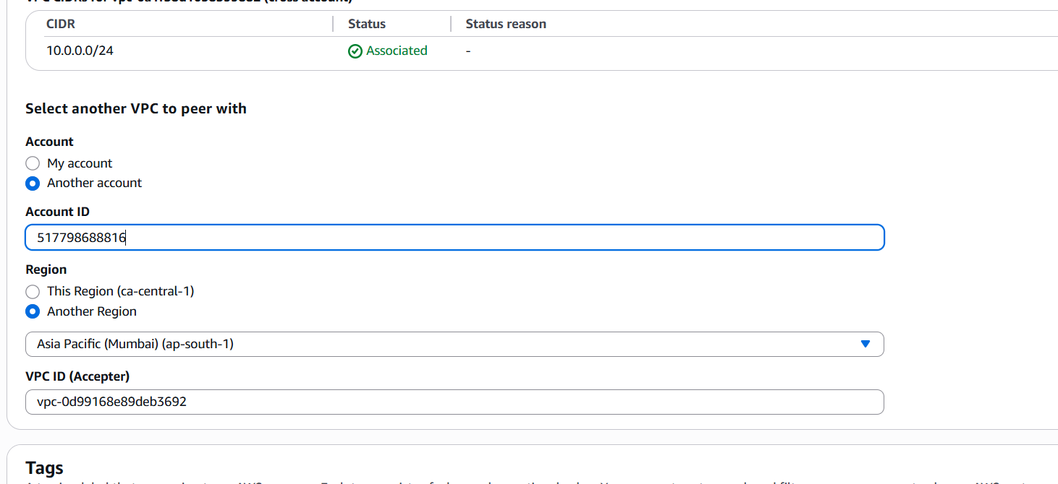

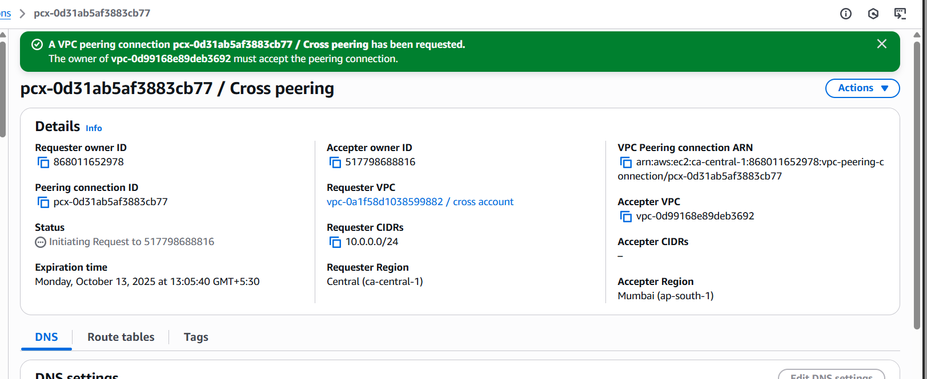

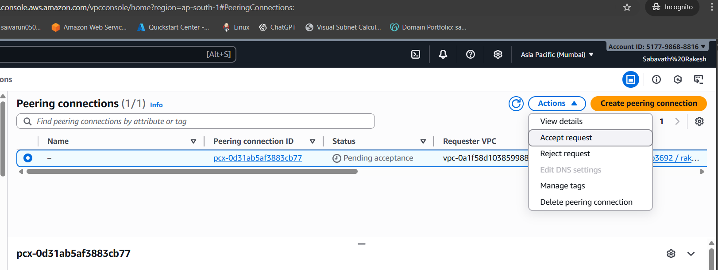

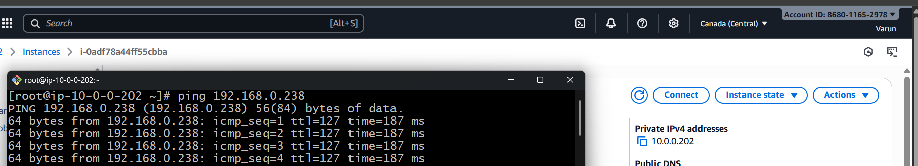

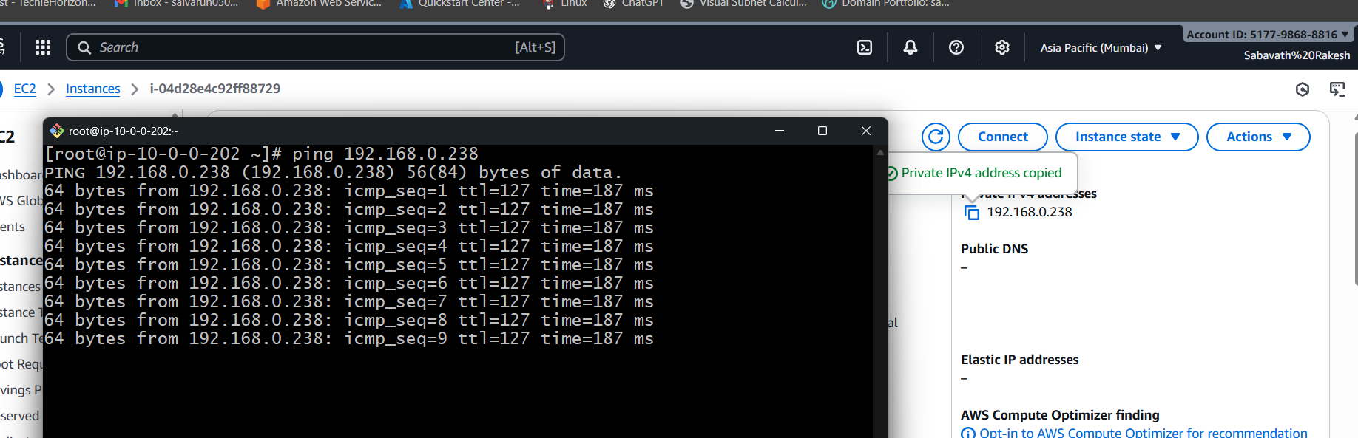

* Create 1 ec2 in canada with vpc connected to it and it should be public.[MY ACCOUNT]
* Create 1 ec2 in mumbai with vpc connected to it and it should be public too.[Friends account]
* Now try to connect Canada instance with Mumbai’s by creating a peering request and accept it from the other end user.
* Once the connection is established configure the same in route tables by giving the vpc ids and peering connection ids in each other.
* Now try to connect to instance in Canada and ping to mumbai’s private ip address.
* We can see the connection establishment between this two regions.

1. Set up a VPC Transit Gateway.

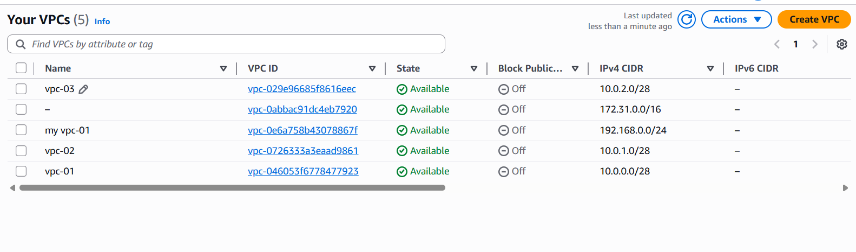

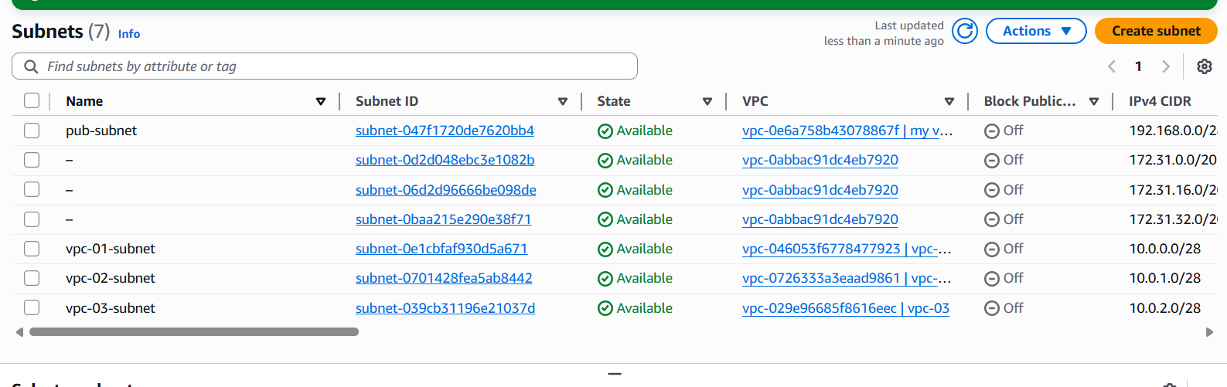

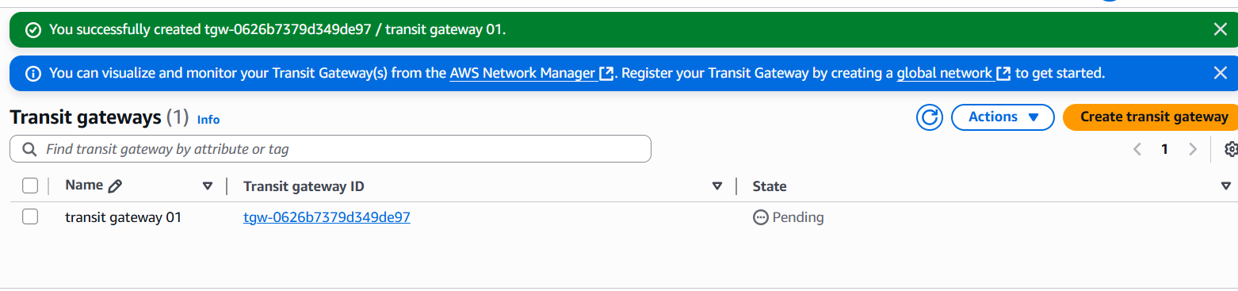

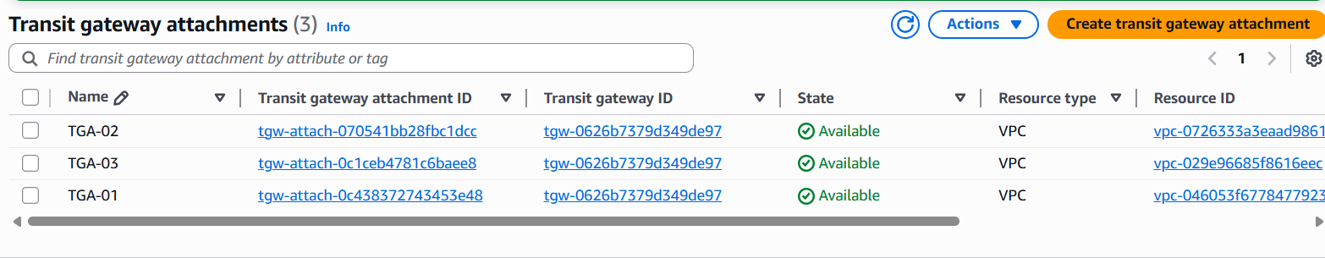

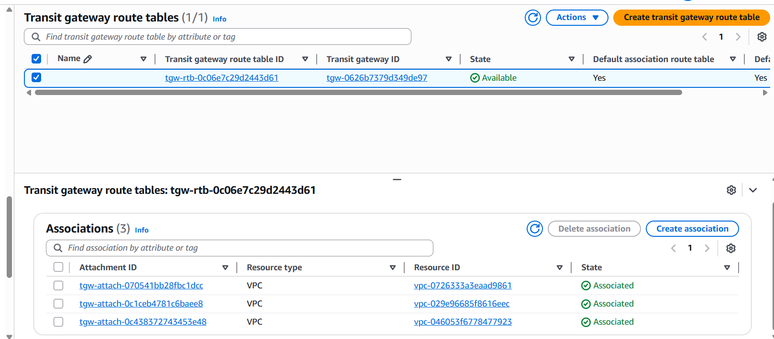

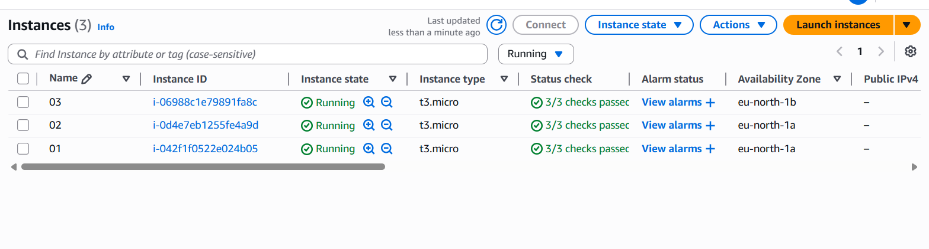

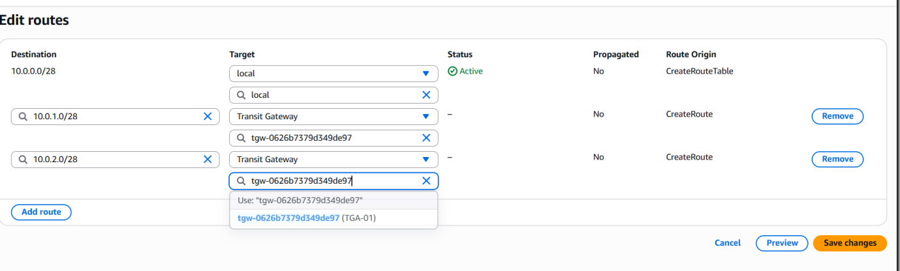

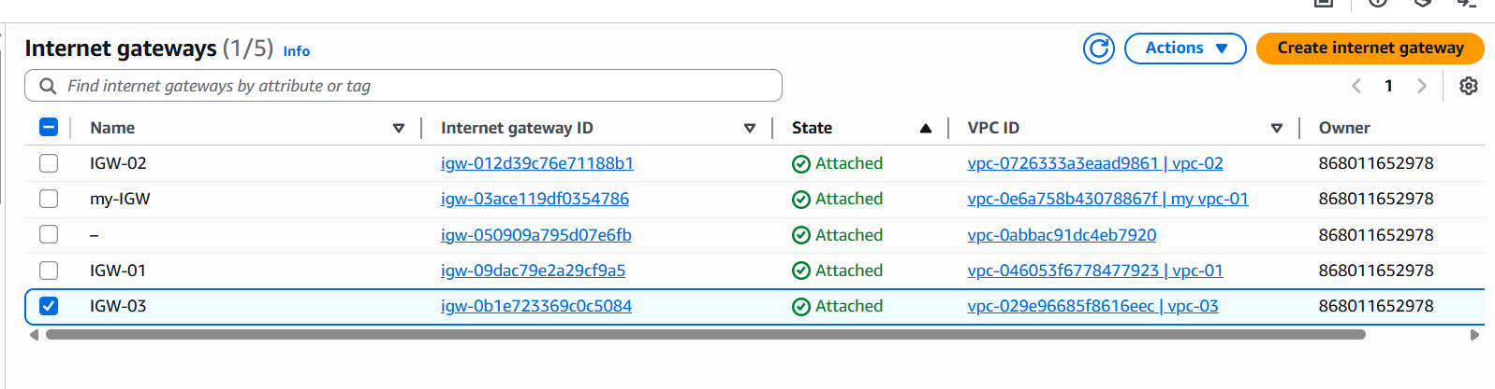

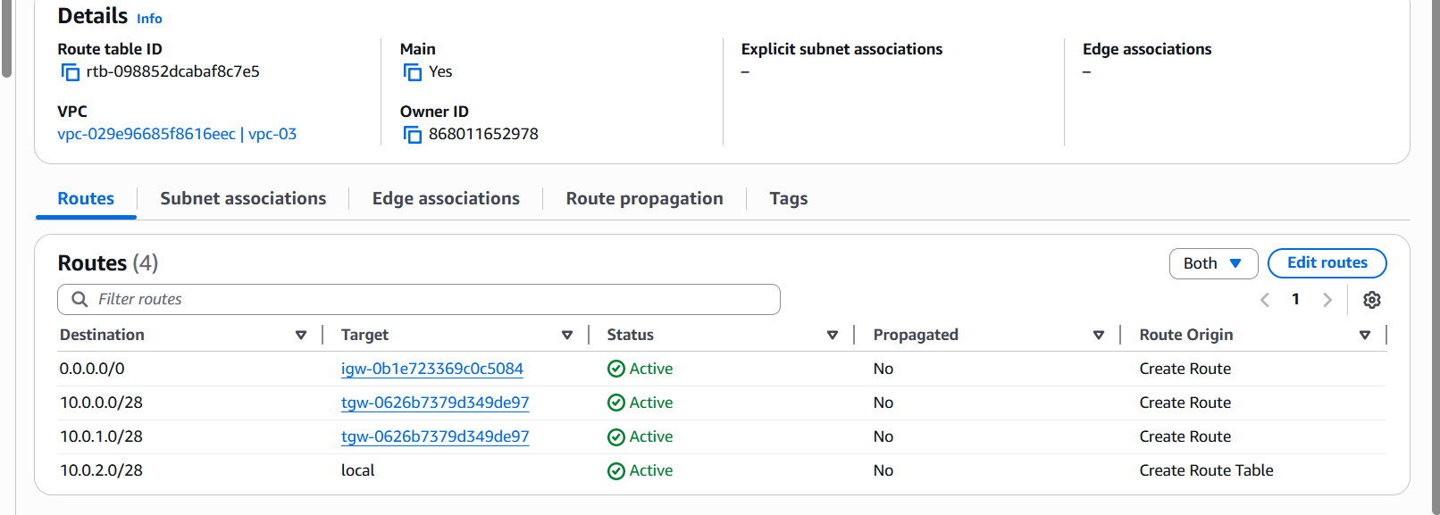

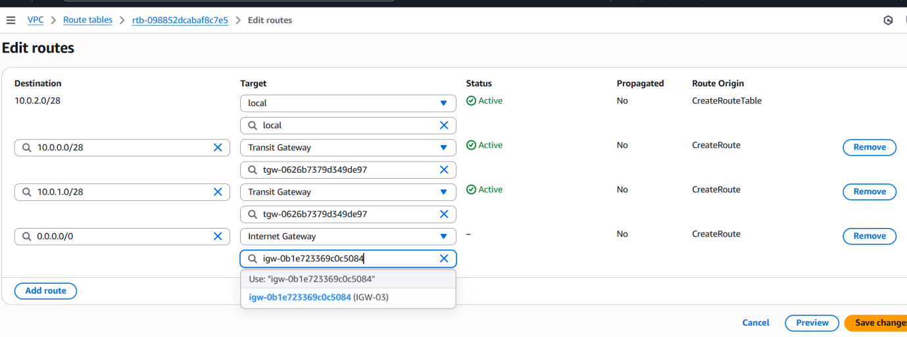

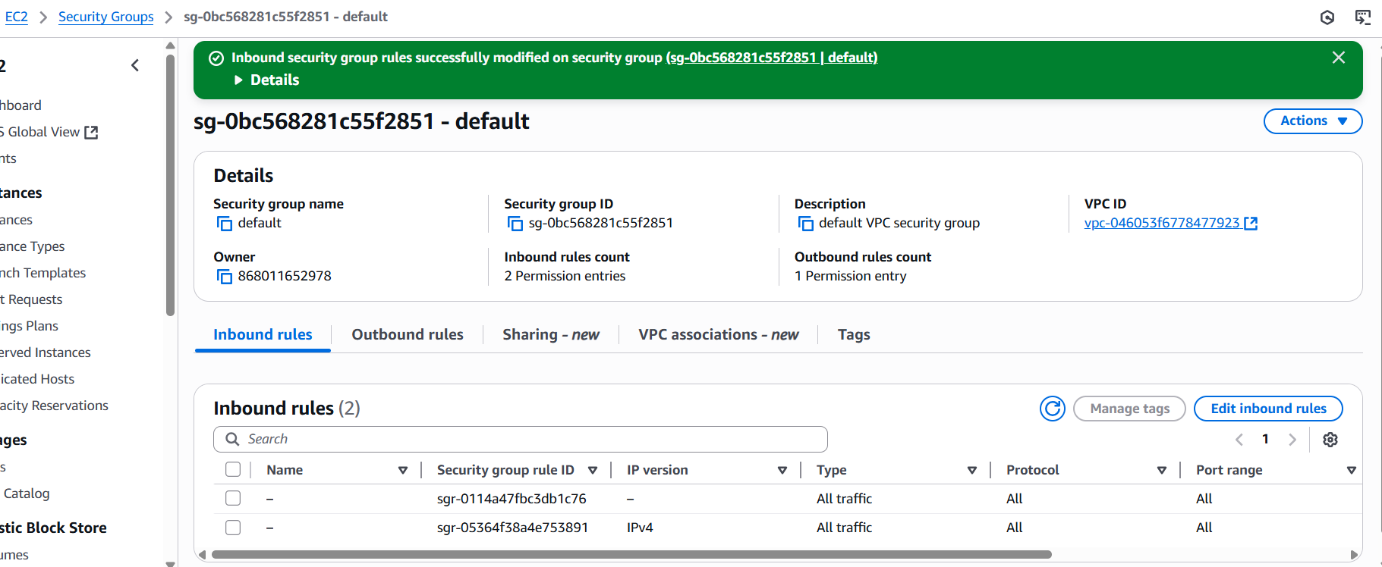

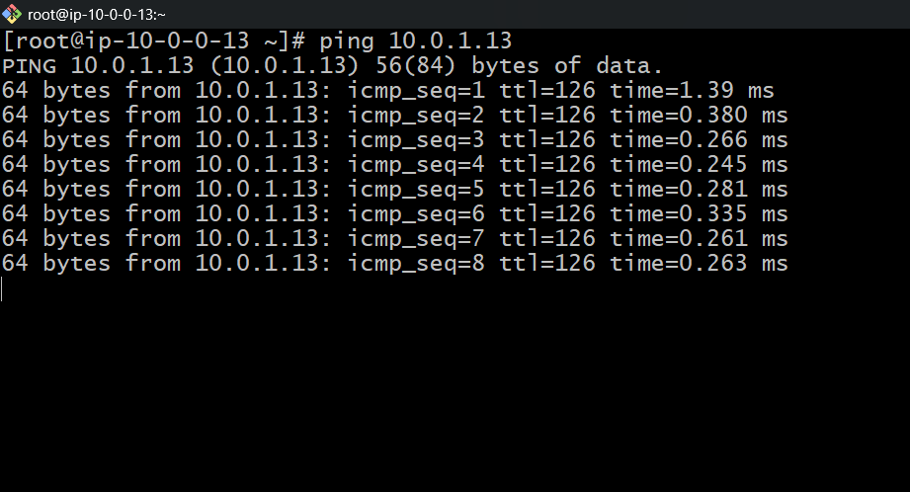

•Create three vpc with one for public and two for the private  
•Create the subnets to the vpc’s created  
•Go to transit gate way create one transit gateway  
•Then create transit gateway atachments to the vpc’s  
•Then launch three instances with three vpc’s  
•No connect to the vpc 1 with the public ip in CLI i.e git bash  
•Then ping the private ip of the other two instances  
•Attach the transit gateway to the public vpc of two other vpc cidr range  
created so that when we try to connect to the vpc try to send to  
particular transit gateway.  
•Do the same to the other vpc attach the vpc cidr range of other vpc –  
target transit gateway  
•Create IGW (internet gate way and for vpc and attach to the routes  
•If it not connecting go to ec2 – security group – add port no all traffic –  
then you can see connection is established to private ec 2 created in CLI  
•Use: ping <ip address private>

1. Set up a VPC Endpoint.

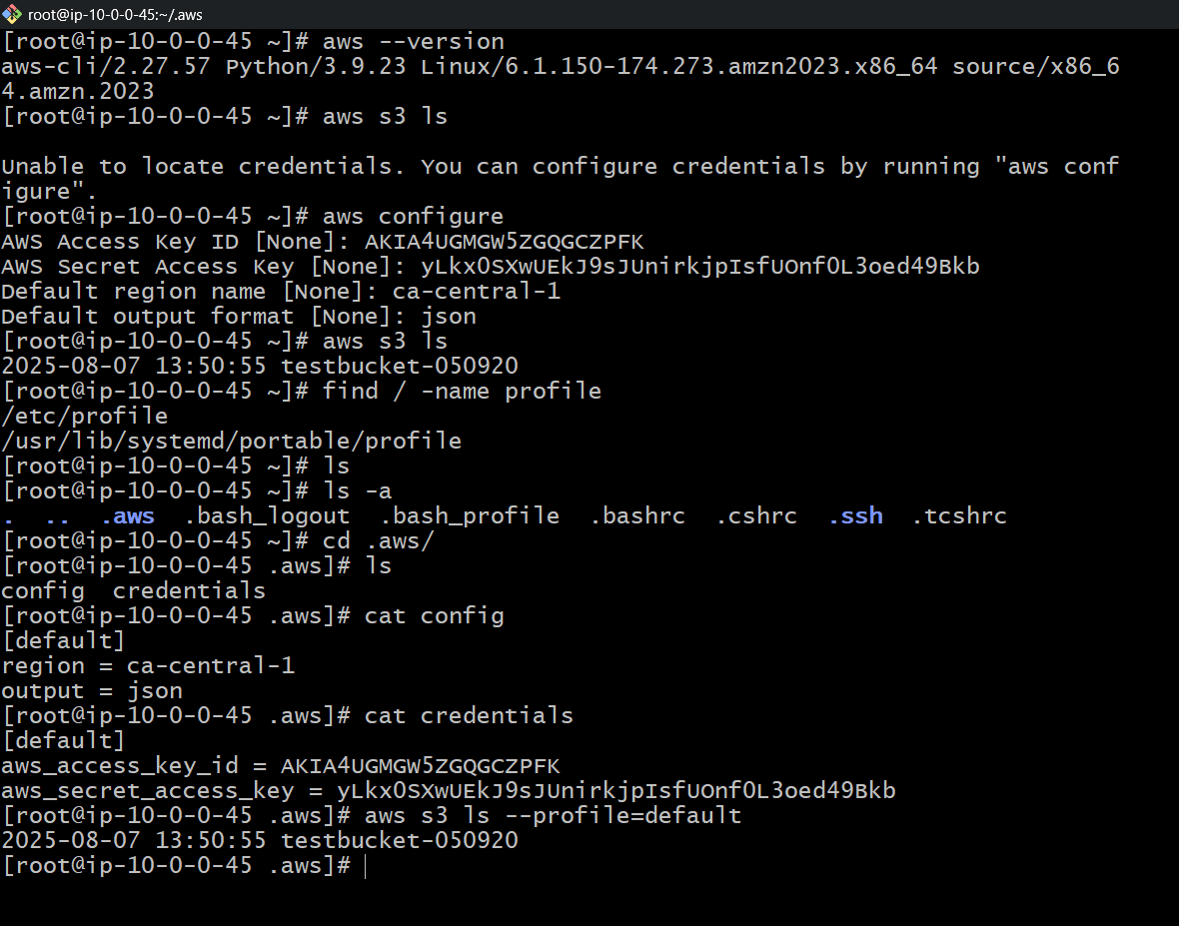

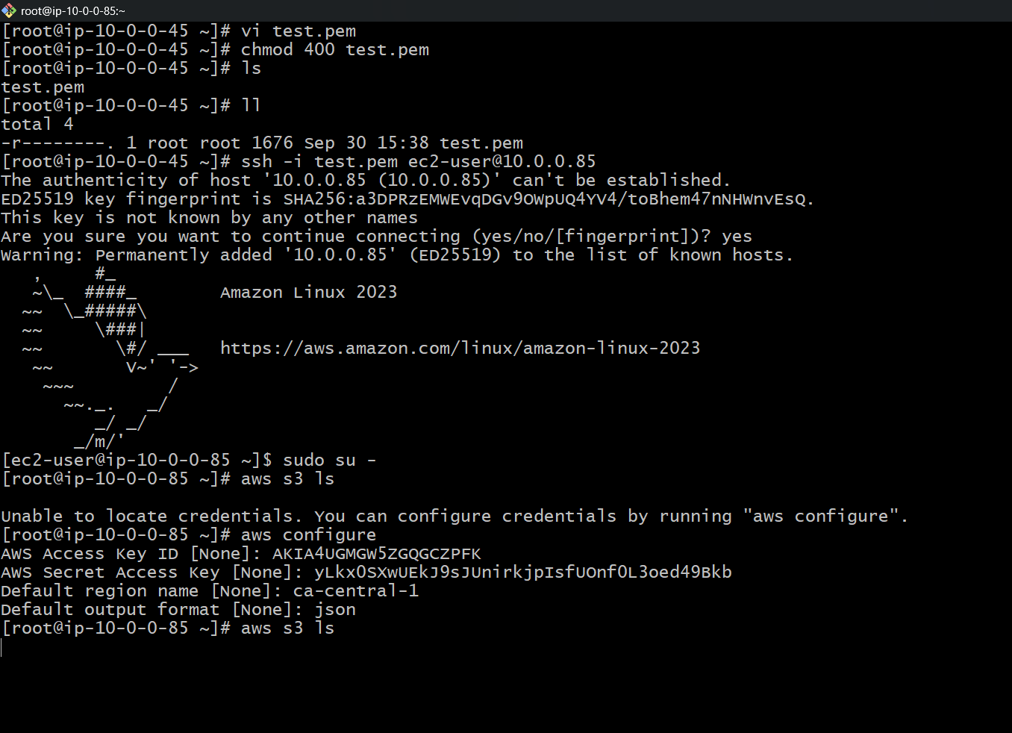

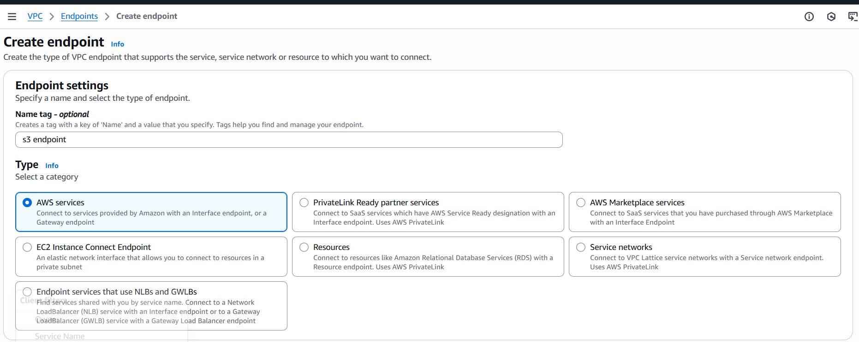

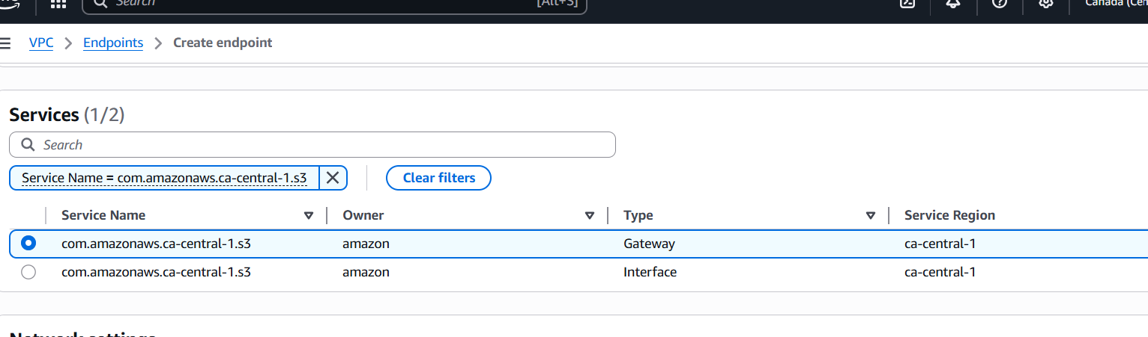

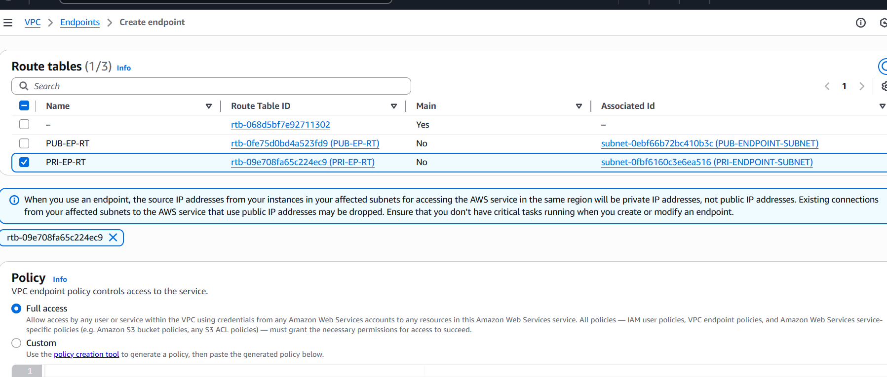

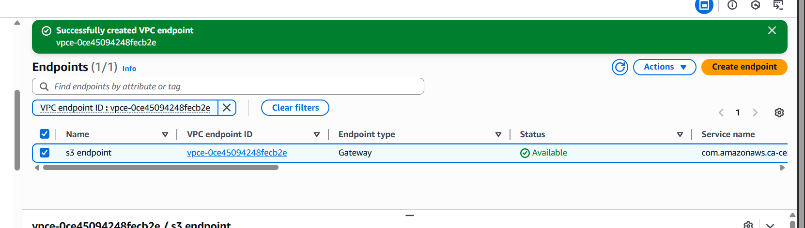

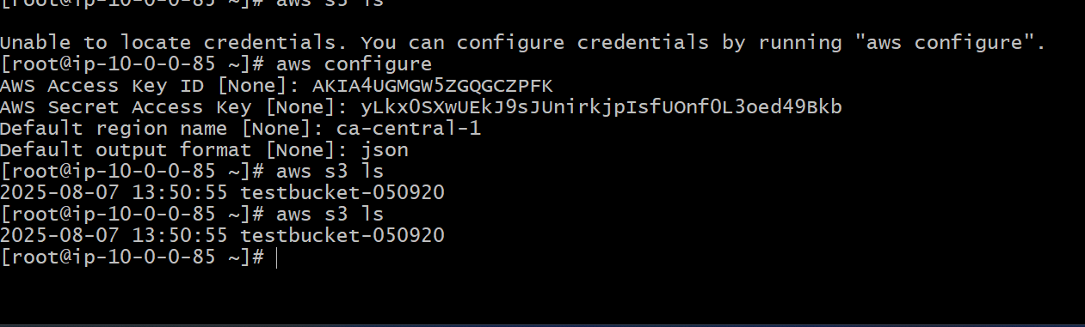

•Create one s3 bucket

•Go to s3 service  
•Create s3 bucket the name of the bucket should be unique,Now connect to public ec2  
•Use git bash   
•Use ssh command to connect.Use aws configure : programmatic acess  
•Provide acess key and secret key to configure  
•Don’t have that then create in security crenditials by searching it then find create key   
there you can create the key

•Provide the details select the output format and region  
•Use : aws s3 ls , you can see that you can acess the s3 bucket in cli  
•Copy the pem key from local use cat to see the key  
•Then create the pem key file and give permission: chmod 400 filename.pem

•After connecting to the private ec2  
•Use aws configure and configure access key and secret key  
•Select output format and region  
•Now go to vpc  
•Navigate to end points  
•Select aws service  
•Then select s3 and end point type expres  
•Then select gateway  
•Create end point the end point has been created  
•Now you can acess the s3 from the private instance : aws s3 ls